**Thyroid Disease Classification Using Machine Learning**

**INTRODUCTION**

Overview

 The authors [20] used a deep neural network (DNN) to predict the thyroid disease classification. The performance evaluation is done on the UCI dataset of 3152 unique samples. The authors reported **99.95% accuracy** when using DNN to classify thyroid disease.

**Tests to evaluate thyroid function include the following:**

* TSH TESTS. The best way to initially test thyroid function is to measure the TSH level in a blood sample
* T4 TESTS. T4 is the main form of thyroid hormone circulating in the blood. ...
* T3 TESTS
* FREE T3.
* REVERSE T3

**Ultrasound**. This imaging technique uses high-frequency sound waves to produce images of your thyroid gland. A thyroid ultrasound provides the best information about the shape and structure of nodules. Doctors may use it to distinguish cysts from solid nodules or to determine if multiple nodules are present.

Based on US patterns including solidity, echogenicity, and suspicious US characteristics, thyroid nodules in the K-TI-RADS system are classified as **high suspicion, intermediate suspicion, low suspicion, and benign**.

**PURPOSE**

The main goals of the symposium entitled “Thyroid Fine-Needle Aspiration: New Classifications and New Interpretations” are the presentation and discussion of the thyroid fine-needle aspiration terminologies most commonly used, an analysis of their respective advantages and limitations, and a statement of how ancillary techniques could reduce the number of indeterminate cases.

Along with an **increase in energy levels and a more stable weight**, your other symptoms should improve as well. Your sex drive may improve, you may sleep better, pain in your muscles and joints may go away and your mood may improve as a result of treatment for low thyroid or other hormone replacement therapy.

**PROBELEM DEFINITION & DESIGN THINKING**

**Empathy Map**

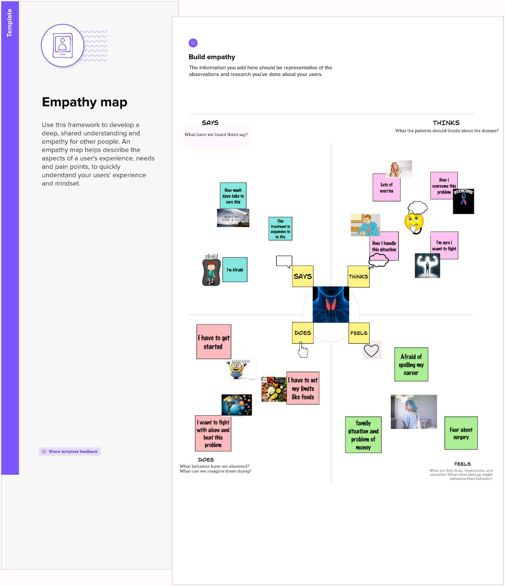

**Ideation & Brainstorming Map**

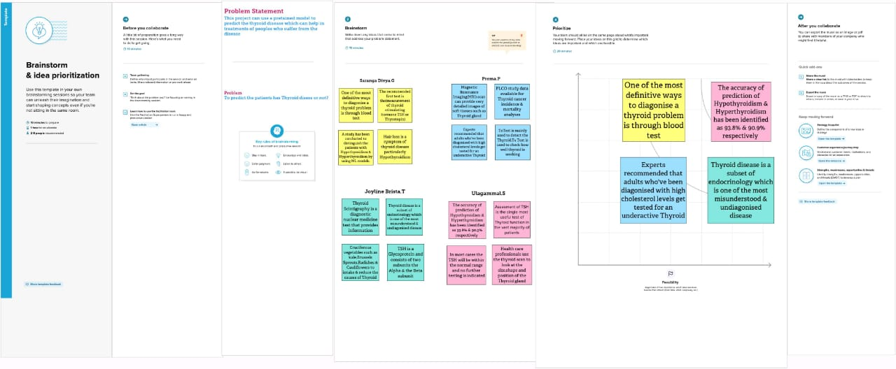

**RESULT**

Import Libraries

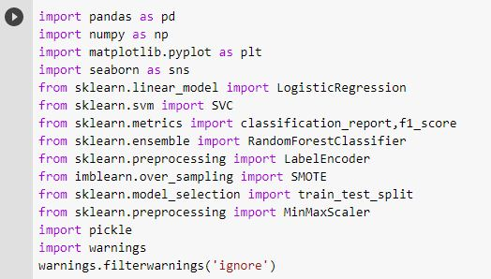

Read data from CSV

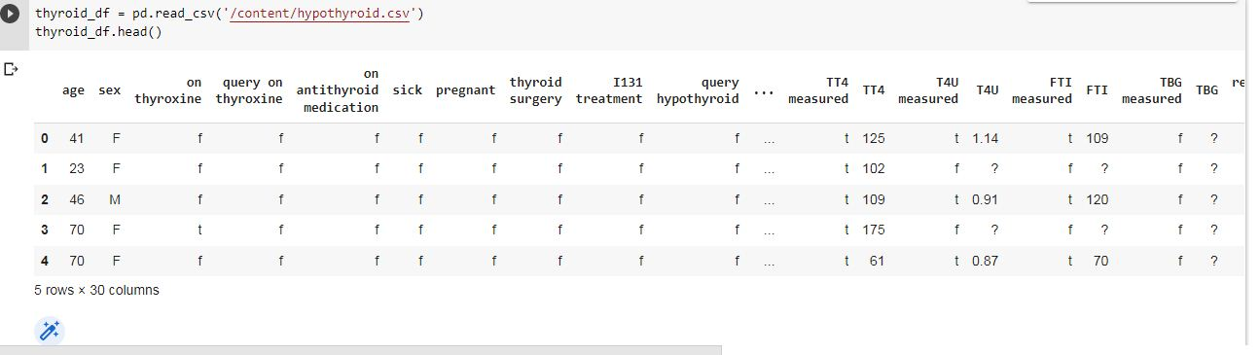

Data Cleaning

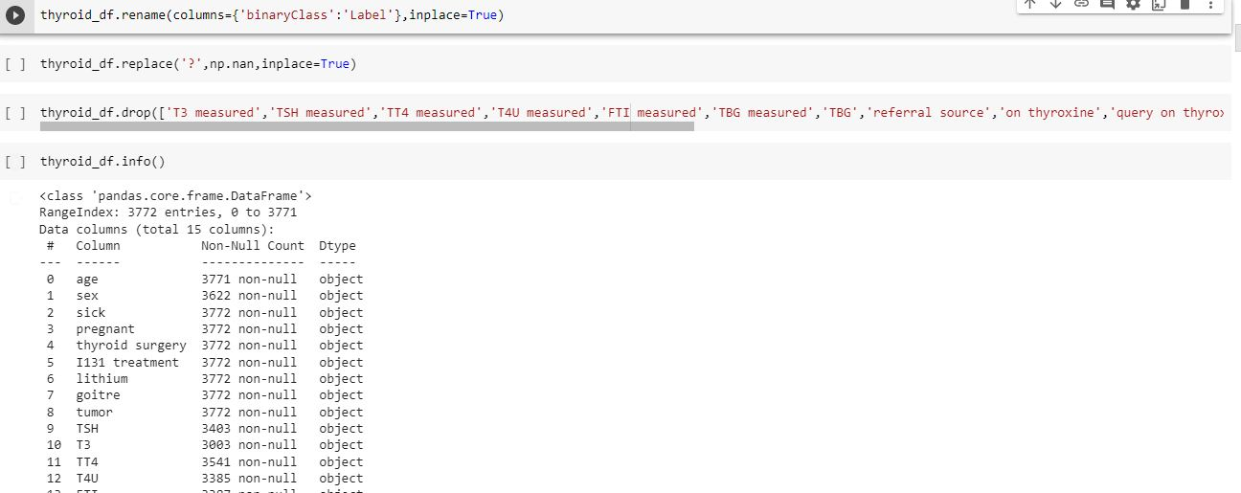

Handling Missing values

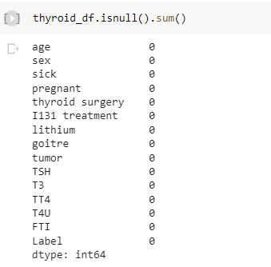

Exploratory Data Analysis

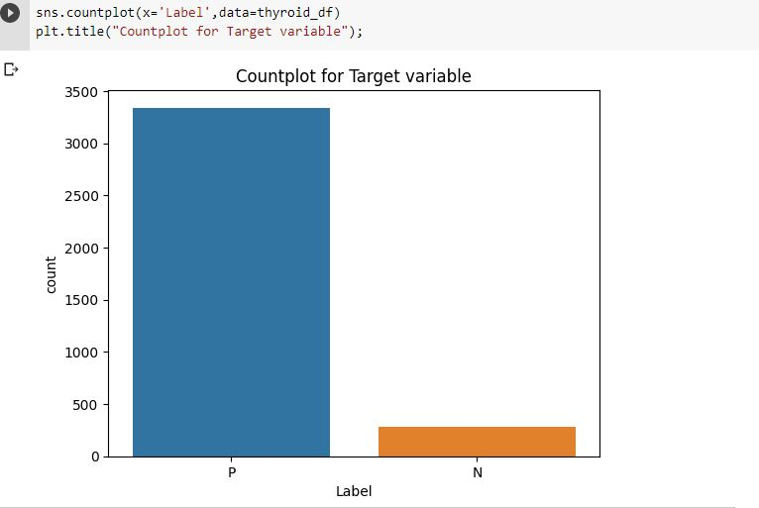**Visual Analysis**

Univariate Analysis

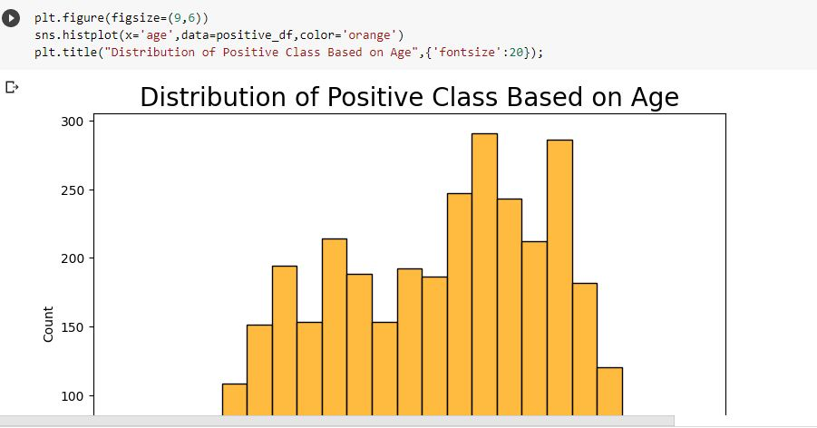

Bivariate Analysis

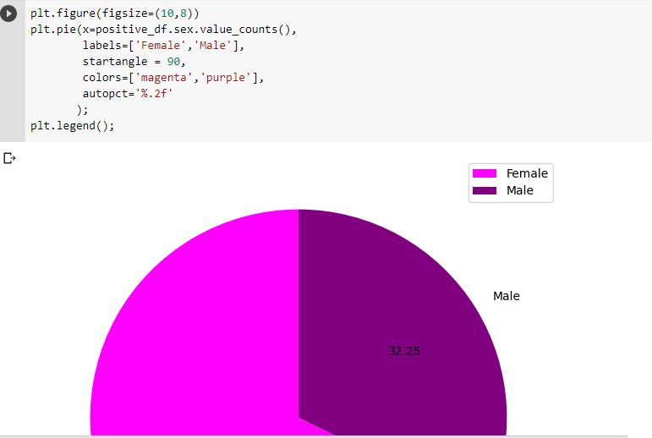

Multivariate Analysis

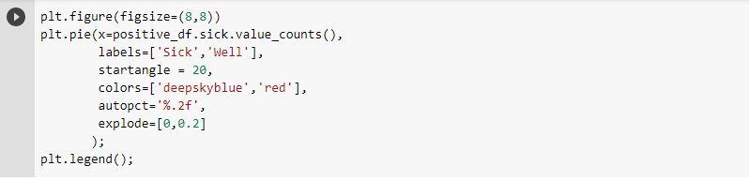

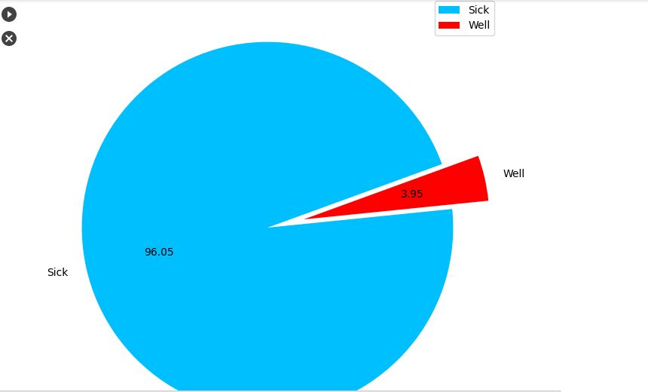

**Transform Non-numerical labels to Numerical labels**

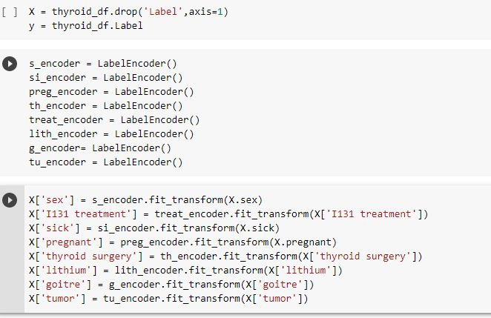

Split original data into training and testing data

C:\Users\admin\Contacts\Desktop\split data.JPG

Handle Imbalance data

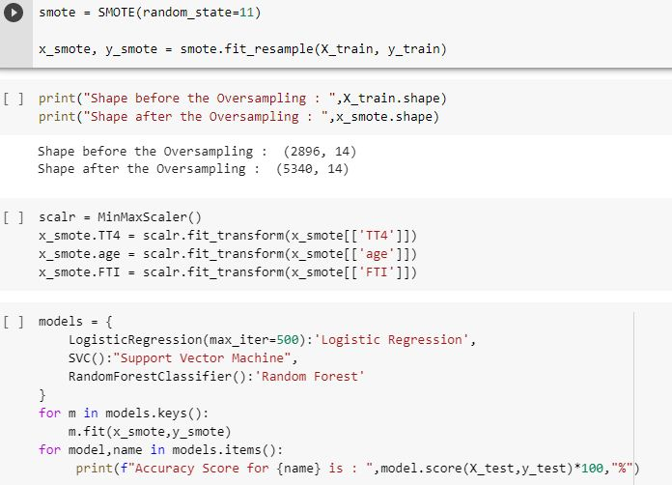

Scaling(Normalization)

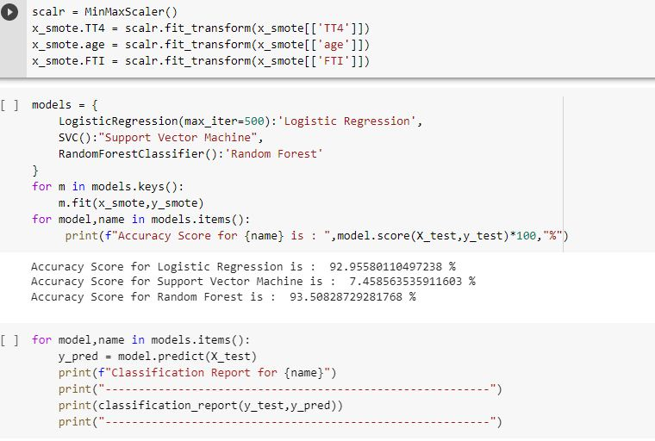

Build Models

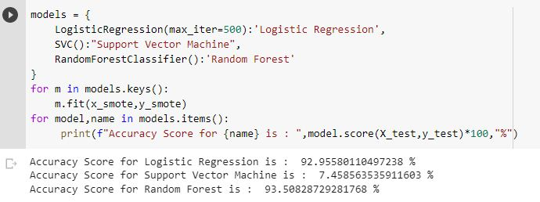

Classification report for each model

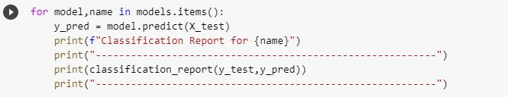

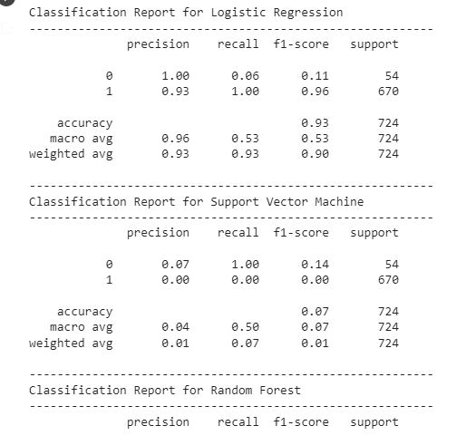

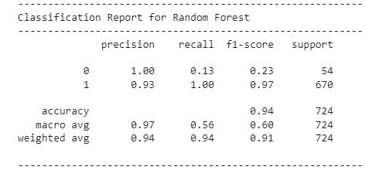

**ADVANTAGES & DISADVANTAGES**

**ADVANTAGES:**

* The main desire of the classification issue is to diagnose the class for new data. Supervised learning is a classification algorithm in data mining. Classification is a machine learning task that predicts the classes according to some constraints.
* Support Vector Machine is one of the managed machine learning algorithm used for both the classification and regression issues and it is usually used for a bit of arrangement problems.
* Score: There is a lots on precision and recall; cannot avoid the other measure of F1, which is a function of precision and recall

**DISADVANTAGES:**

* Classifications of goiter based on thyroid hormone levels include: **Toxic goiter**: This goiter happens when your thyroid is enlarged and produces too much thyroid hormone. Nontoxic goiter: If you have an enlarged thyroid but normal thyroid levels (euthyroid), it's a nontoxic goiter.
* When the thyroid makes too much thyroid hormone, your body uses energy too quickly. This is called hyperthyroidism. Using energy too quickly will do more than make you tired it can make your heart beat faster, cause you to lose weight without trying and even make you feel nervous.
* Other potential thyroid medication side effects are less common, but in most cases they're caused by excessive doses of thyroid hormone.

**APPLICATIONS:**

* A TSH test is used **to find out how well your thyroid is working**. It can tell if you have hyperthyroidism (too much thyroid hormone) or hypothyroidism (too little thyroid hormone) in your blood. But a TSH test can't show what is causing a thyroid problem.
* Atherosclerosis is a major cause of mortality throughout the western world, despite the existence of drugs that lower cholesterol.
* Selective thyroid hormone **receptor modulation** is a promising new strategy for the prevention and treatement of atherosclerosis and obesity in humans.

**CONCLUSION**

Thyroid disease is one of the diseases that afflict the world’s population, and the number of cases of this disease is increasing. Because of medical reports that show serious imbalances in thyroid diseases, ourstudy deals with the classification of thyroid disease between hyperthyroidism and hypothyroidism. This disease was classified using algorithms. Machine learning showed us good results using several algorithmsand was built in the form of two models.

**FUTURE SCOPE**

Thyroid endocrinology aims to advance our knowledge of the physiopathology of the thyroid gland. The thyroidologist, like all physicians concerned with internal medicine, lives in an environment of increasing specialization and multiplying subspecialties. This applies also to thyroid research, in which the divide between “basic” and “clinical” scientists is ofen wider than it should be.

**APPENDIX**

Source Code:

HTML Files: 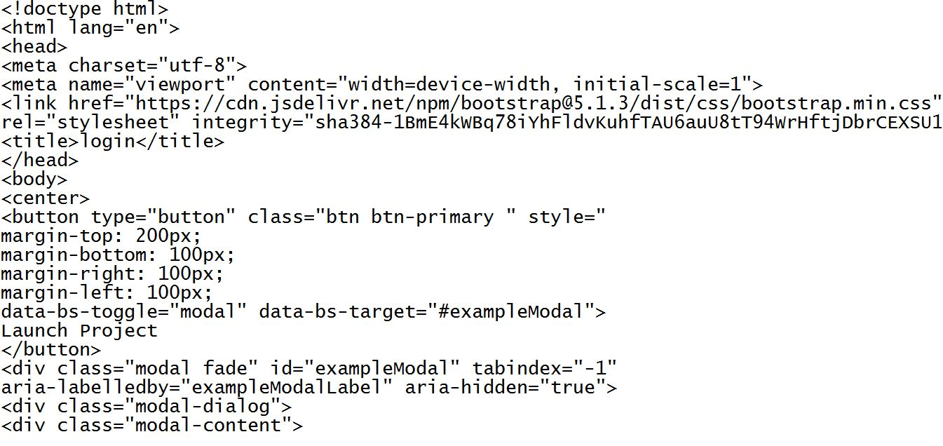

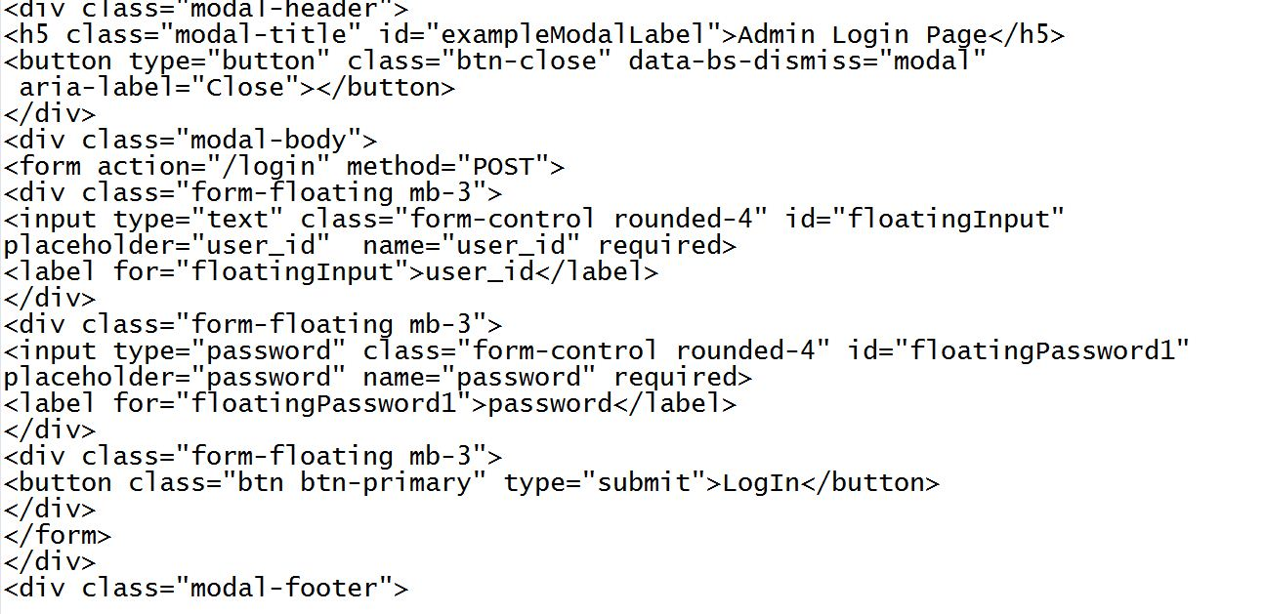

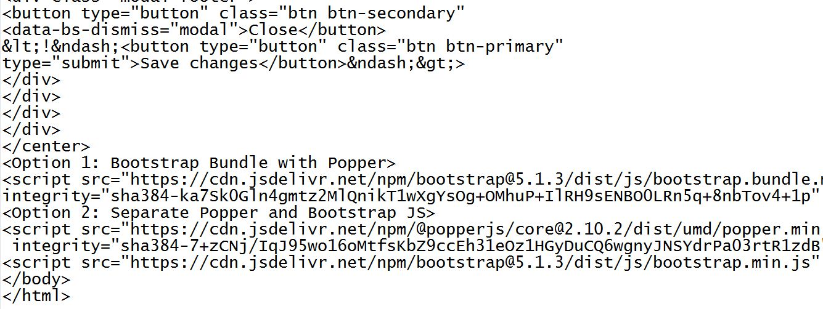

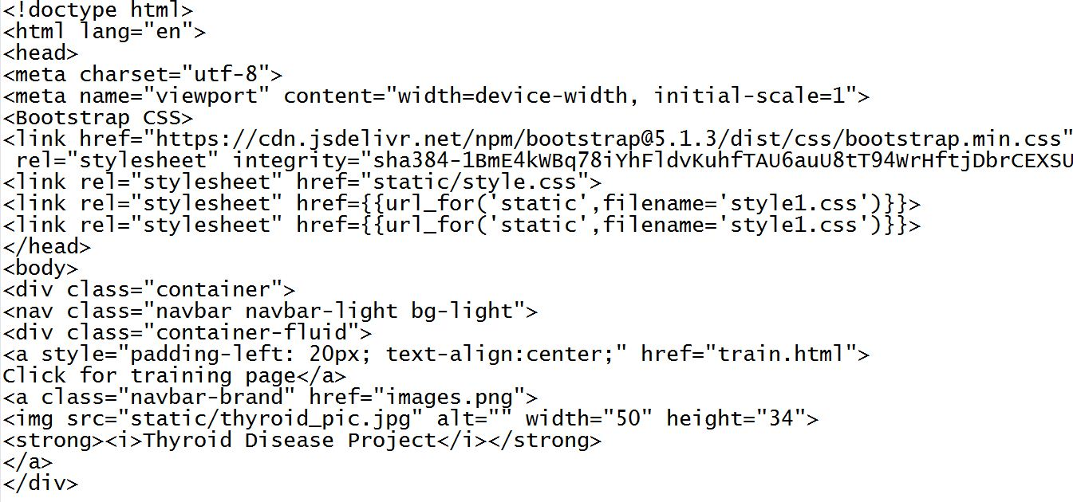

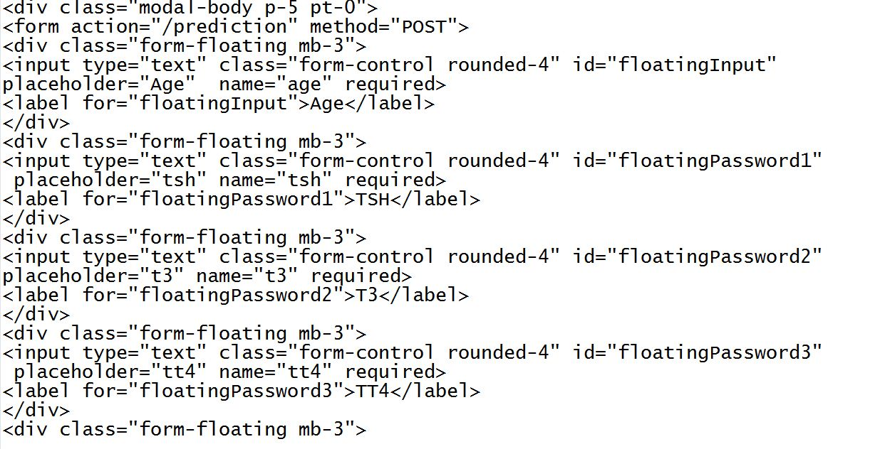

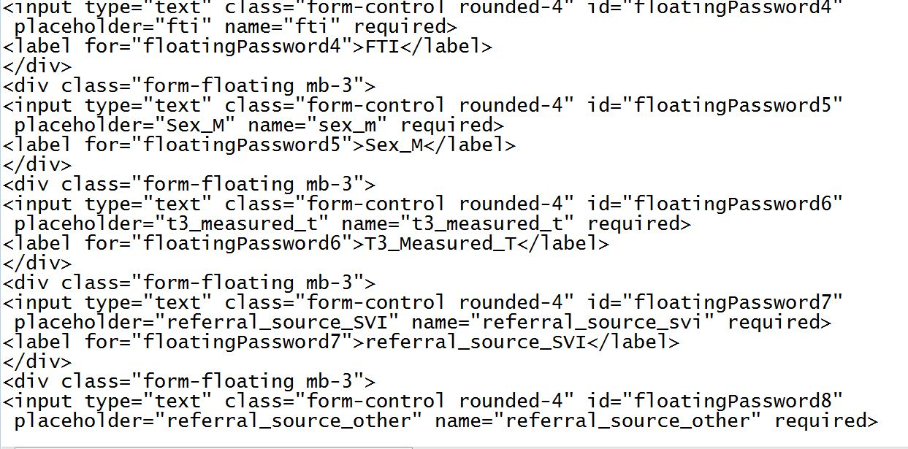

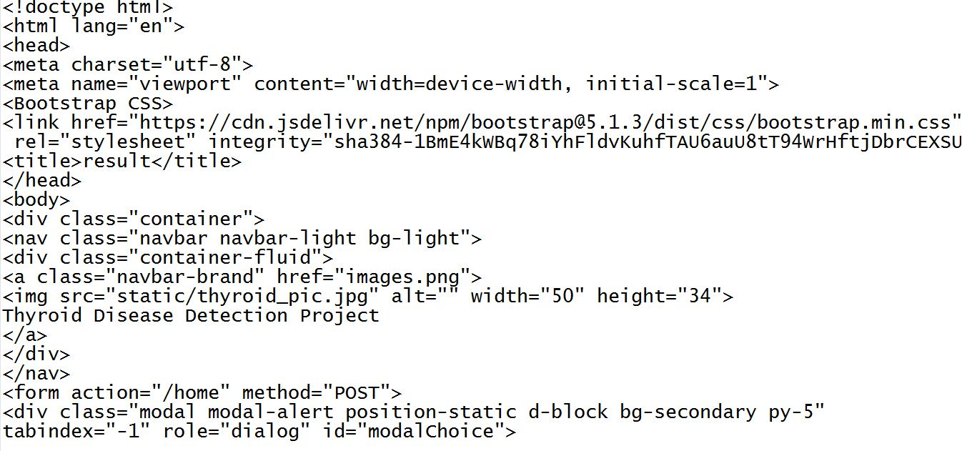

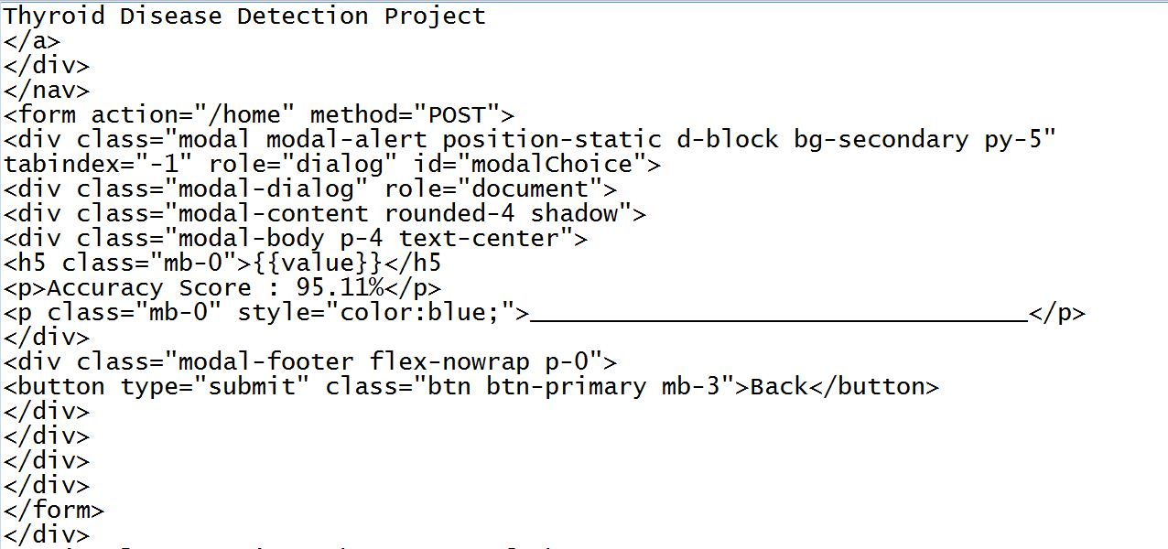

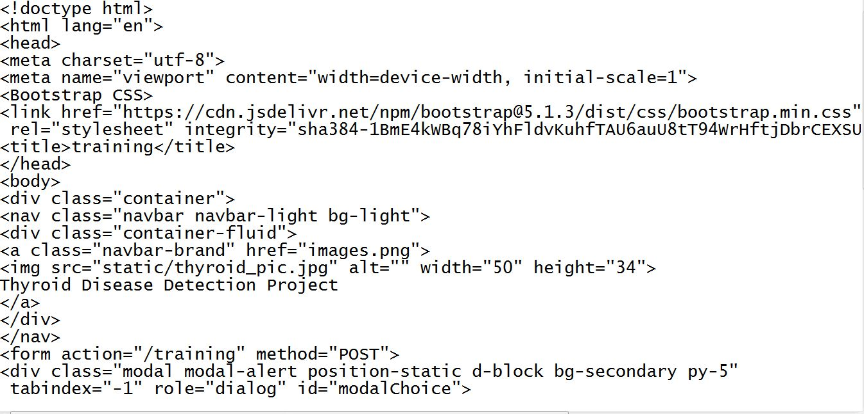

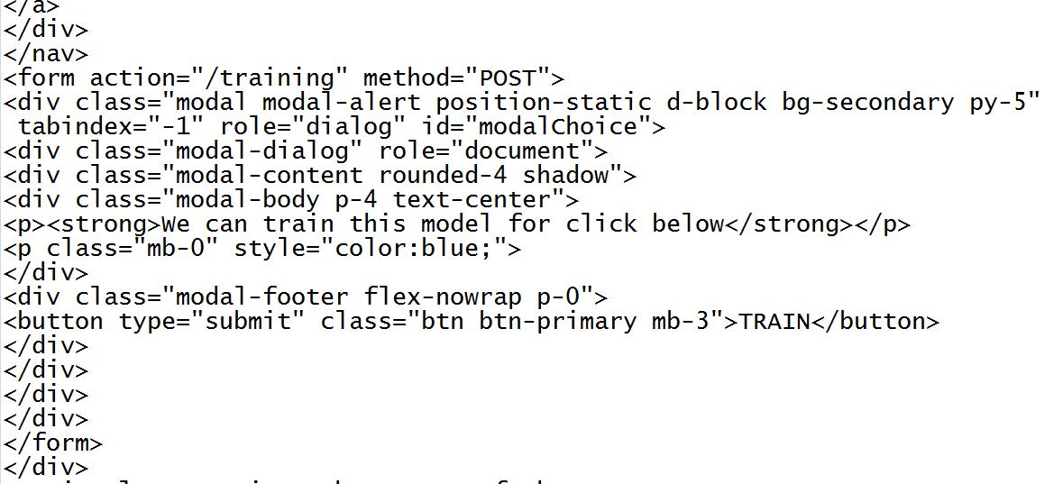

Flask Files:

